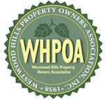
westwood hills property owners association newsletter fall 2014

Dear Neighbors –

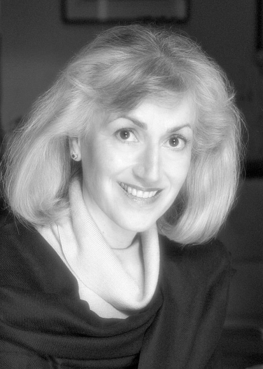
After five challenging years for our neighborhood, the 405/Sepulveda project is nearing completion—we can all breathe a sigh of relief after having to deal with the myriad impacts of this massive project. However, new transportation and traffic issues loom on the horizon for the Westside, as reported by our Traffic Chairperson, Debbie Nussbaum, below.

That’s why, as always, it’s important that you attend this year’s Annual Meeting on Wednesday, October 15! We need a big turnout of caring neighbors to convince our elected representatives that they must be responsive to our continuing concerns.

Our featured speakers include our Los Angeles County Supervisor Zev Yaroslavsky (who also sits on the Metro Board of Directors, which oversees most of the regional transportation system); our Councilman Paul Koretz (who can help us with City agencies that approve traffic mitigations and landscaping); and our LAPD Senior Lead Officer Chris Ragsdale (with his annual update on security and crime in the local area).

This is your chance to ask questions and demand results from our elected representatives.

Our annual meeting this year marks the last time that Zev Yaroslavsky will be speaking to all our members as our County Supervisor, because his term expires in December. Zev has represented the Westside for nearly 40 years—first as our City Councilman (1975–1994), then since 1994 as our County Supervisor. We’ve included a brief look at Zev’s career below.

Zev and his staff (especially his wonderful deputy Vivian Rescalvo) have always been extremely constituent oriented. The last couple of years, they have really gone to bat for us with Metro on several 405 construction issues. It will be with great regret—and many thanks for his years of dedication—that we say goodbye to Zev as one of our elected representatives.

We’re meeting in the same venue as last year: the Westwood Presbyterian Church, 10822 Wilshire Blvd. (the south side of Wilshire, next door to the new iPic Movie Theater). There is plenty of surface parking on site.

Our Annual Meeting is always a great opportunity for us to get together in person—socialize, enjoy some delicious munchies, meet new neighbors, renew old acquaintances, and catch up on local news.

I look forward to seeing you all on October 15!

Best regards,
Terry

Life after the 405 Construction-Back to Normal?

The 405 construction is wrapping up and hopefully by December all the closures and construction will be over. Was it worth it? It was definitely challenging and educational for all of us who live in Westwood Hills. We have gained an in-depth understanding of what is involved with infrastructure construction! We witnessed destruction of the environment in the name of environmental improvements. We had to fight for every replacement tree and vine from Wilshire to Sunset and for implementation of mitigations promised in the 405 Project EIR as issues on construction noise, air quality (dust), work hours, and landscaping arose over and over.
The Transit Revolution seeks to improve passenger travel time and encourage a shift from cars to public transit. What kind of transportation projects should be funded: light rail, buses, grand boulevards, bike- and car- sharing, sidewalks, green streets, or connecting more people to transportation? An email today asked me that exact question. Well, for those of us on the Westside, let’s review what is currently under construction and what is planned:
Wilshire Bus Rapid Transit (BRT): Bus Only lanes being configured along Wilshire Blvd. will provide speedier bus service along Wilshire during rush hour travel (7am-9am and 4pm-7pm Monday through Friday). The curbside Bus Only lanes will extend from Santa Monica’s city line to downtown LA with two exceptions: the section east of Westwood Village (Selby) through the city of Beverly Hills and Veteran Ave. to Bonsall Ave. (avoiding conflicts with 405 on and off ramps.) This means motorists will have one less traffic lane during rush hour. Bus Only lane construction underway on Wilshire by the VA currently reduces westbound Wilshire to 2 lanes.
Expo light rail phase 2 to Santa Monica slated to be operational sometime in 2016 will carry passengers from Santa Monica to downtown LA in less than 50 minutes. The closest Expo stations to us will be at Westwood/Rancho Park and at Exposition/Sepulveda. Unfortunately, neither station will have parking lots.

Subway Purple line extension is under construction in the Wilshire/La Brea station area, with a completion target of 2023. The Westwood subway station stop, to be built under Wilshire Blvd. between Westwood Blvd. and UCLA’s Parking Lot 36, west of Gayley, currently is scheduled to start construction in 2027 and continue to 2035.
Complete Streets Law, passed in 2008, directs local governments to provide better conditions for pedestrians and cyclists while emphasizing public transportation, and to create incentives for new mixed-use and mixed-income residential developments along boulevards in order to build a transit user base. LA improvements to comply are to be called “Grand Boulevards.”
Bicycles: A new bicycle safety law requires motorists to give cyclists at least 3 feet of space when passing them from behind. If it's not safe to pass, drivers must slow down to a reasonable speed and then pass when the cyclist is deemed not in danger.

Bike lanes: In the coming years these will quadruple, increasing to 1,684 miles. Where the lanes should be located is a controversial issue at the moment. Some think bike lanes would be safer and have less impact on traffic if they were located on side streets. Others argue that cyclists deserve equal access to major traffic arteries, even if traffic lanes must be eliminated to accommodate added bike lanes.
Tunnel connecting the San Fernando Valley with the Westside under the Sepulveda Pass to include heavy or light rail transit and vehicle toll lanes, has been proposed and has support among business groups and others in the Valley. So far, no funding source.
Street Cars for Sepulveda Blvd., south of Wilshire, and Lincoln Blvd., are part of the Westside Mobility Plan discussion.
Changes in zoning around transit corridors are proposed to allow greater housing density and more mixed-use development. Metro/LADOT/city planners envision a future where people depend on mass transit and walk the first and last mile from home to public transportation
Debbie Nussbaum, Traffic Committee Chair

They’ll grow!!!
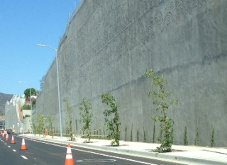

Thanks to our elected officials for supporting our sustained effort--spearheaded by WHPOA Traffic Chair Debbie Nussbaum--to persuade LADOT to permit Metro to plant trees and vines to soften the trench effect of the retaining and freeway walls north of Montana. Without WHPOA’s efforts no trees and few vines would have been planted in this area, despite Caltrans’ early promises to the contrary. Supervisor Zev Yaroslavsky’s office stepped in at the last minute with funds to make addition of the skyrocket junipers planted south of Cashmere possible. WHPOA would like to see at least some of the trees required to replace 700+ trees removed for the project planted in Westwood Hills to restore street trees in the neighborhood lost to disease.

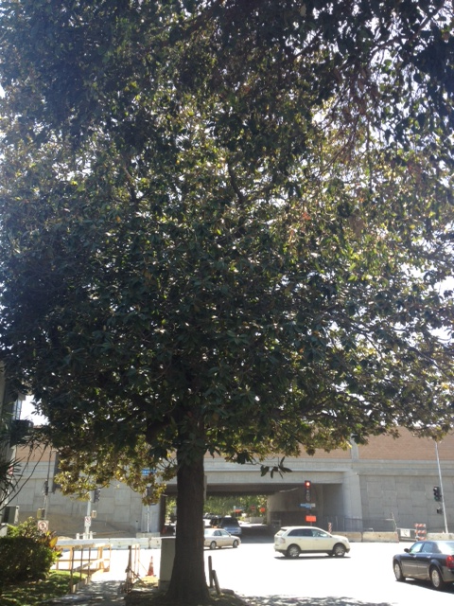
This magnolia at Montana and Sepulveda was saved from demolition by the timely intervention of WHPOA and Councilman Paul Koretz.
Streets and Potholes
In recent years, WHPOA has campaigned to steadily to bring the condition of our streets to the attention of the powers that be. Perhaps as a result, several potholes were patched on S. Bentley last year and two streets were placed on the schedule for resurfacing this year. So far no street work has taken place in our area, although many streets in surrounding areas have been repaired or resurfaced. Now that the 405 construction has moved on, the time seems right to begin upgrade of our 90-year-old infrastructure. Use the City’s new app, MyLA311, to report potholes and street repaving needs to the Bureau of Street Services.

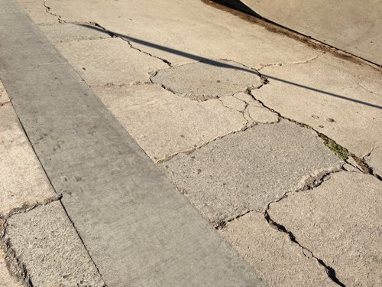

Who You Gonna Call?
Our CD5 Council office is always a great help when we are in need of City Services and this fall we sadly say goodby to one of the most helpful staffers--long-time staff-member Joan Pelico, (213) 473-7005, who leaves in December to seek election as Councilperson for CD 4. David Hersch, david.hersch@lacity.org, currently Deputy Chief of Staff, will take over Joan’s duties. Some changes may be in the offing in our Westside Deputy, who is presently extremely knowledgeable, highly-responsive and super effective Kate Hennigan. More information about the CD5 staff is available on-line at CD5.lacity.org. Daniel Tamm, (213) 978-0836, daniel.tamm@lacity.org continues as the westside representative for the Mayor’s office. To report service needs, you may also call 311. Always dial 911 to report accidents or crimes in progress.

Important! Plan to Attend!

WHPOA ANNUAL MEETING

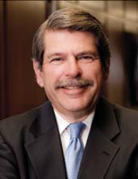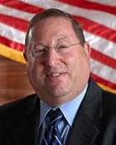

Supervisor Yaroslavsky & Councilmember Koretz

WEDNESDAY, OCTOBER 15, 2014

6:30 p.m. Socializing 7 p.m. Meeting begins

Westwood Presbyterian Church

10822 Wilshire Blvd. (south side of Wilshire next to iPic Movie Theater/Tanzy Restaurant)

Thanks to our generous sponsors:
simplethings, the wonderful little sandwich, salad and pie shop in Westwood Village for their kind donation of yummie pies. simplethings is located at 10874 Kinross Avenue
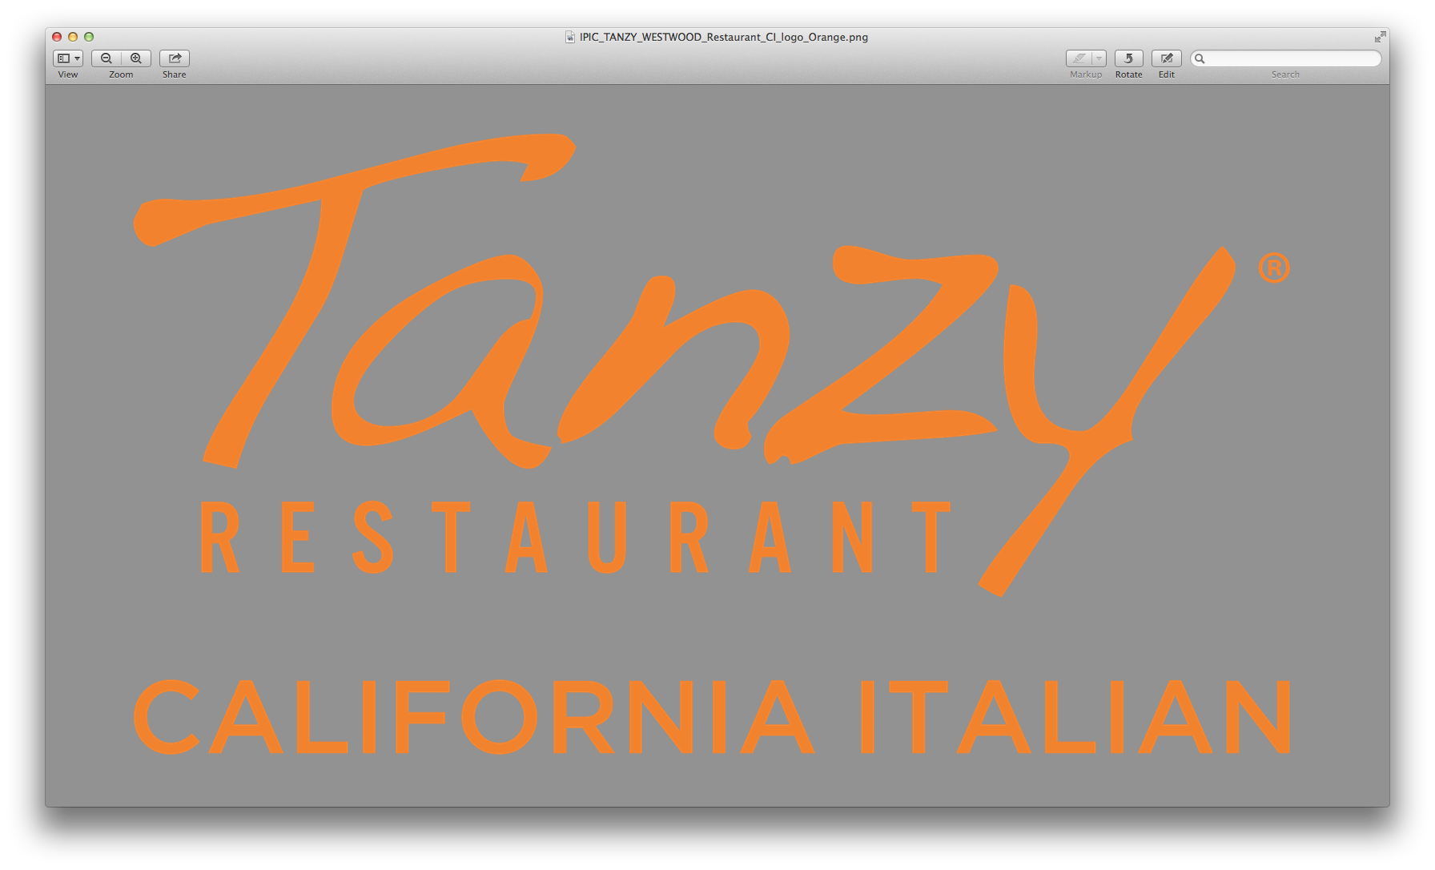
Thoughtfully Sourced and Artfully Prepared. Tanzy offers fresh and flavorful dishes where ingredients are the star, an approach to California Italian cuisine that makes Tanzy a unique addition to the Los Angeles dining scene. http://tanzyrestaurant.com

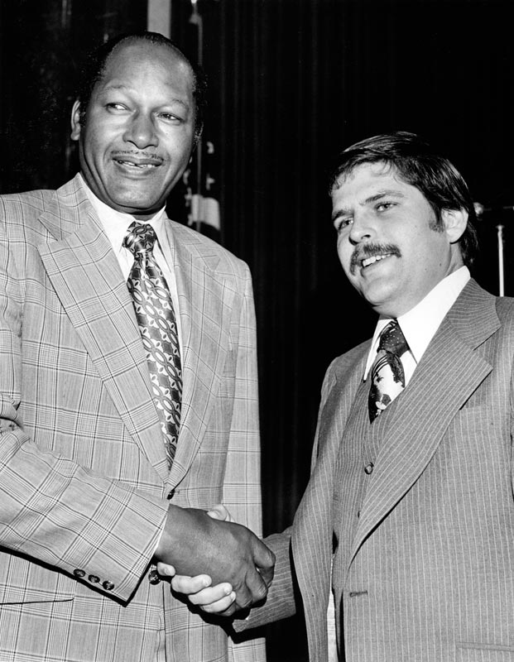
THANK YOU, ZEV!

During a career in public life spanning nearly four decades, Supervisor Zev Yaroslavsky has been at the forefront of Los Angeles County’s biggest issues, from transportation to the environment to health care to the arts. He has been a pioneering advocate for the region’s homeless population and has played a key role in efforts to reform the county’s law enforcement agencies. Throughout his forty years in office, he has been a good friend to Westwood and the residents of Westwood Hills.
He deftly balanced competing interests Westwood: residents and homeowners who needed to protect their property values and quality of life; developers and business interests who wanted quick profits; and UCLA which wanted to grow.
Zev’s leadership and commitment to good public policy is reflected in Westwood today: developers must limit the height of buildings next to single-family residences and pay fees to mitigate extra traffic; increases in future development are tied to available infrastructure; UCLA voluntarily restricts campus-generated trips; historic buildings in central Westwood Village are protected and new apartment development in areas adjacent to campus is limited. Westwood has a large and well-used public park, and VA land is protected by County zoning. Thanks to Zev, Veteran Ave. is not yet a super-highway.
Born December 21, 1948 in Los Angeles, Zev was the son of Jewish immigrants from Russia. He grew up in Boyle Heights, attended Fairfax High, and enrolled at UCLA, earning a BA in Economics and History and a M.A. in British Imperial History.
Zev was first elected to office in 1975, stunning the political establishment by winning the Los Angeles City Council’s coveted 5th District seat at the age of 26. But those who were paying attention knew already that politically Zev was on a fast track. Before he had even graduated from UCLA, Zev had formed the California Students for Soviet Jews. In 1971 he became executive director of the Southern California Council on Soviet Jewry, and by age 23, Zev became a leader of protests – he picketed Soviet athletes, the Bolshoi Ballet, led a protest march or two, supported a campaign to burn Standard Oil credit cards.
When he took his oath of office, then Mayor Thomas Bradley joked that he was “part of the establishment now.”
One of his most important contributions to Westwood came in the form of two landmark initiatives authored with his colleague, the late Councilman Marvin Braude: one was Proposition U, which cut in half the size of new commercial developments permitted near residential neighborhoods, and Proposition O, which banned oil drilling along the city’s coastline.
After five terms as a Councilman, Zev was elected in 1994 to the five-member Los Angeles County Board of Supervisors, replacing retiring Ed Edelman, whom he had also replaced as City Councilman.
As a member of the Board of Supervisors, Zev emerged as a leader on fiscal, health care, transportation, cultural and environmental matters. He authored the 1996 Proposition ‘A’ park bond, which resulted in the preservation of a broad swath of rural open space and the development of urban parks throughout the county. He also authored the 2002 Proposition ‘B’ trauma tax, approved by more than 73% of county voters—a measure credited with saving two public hospitals from potential closure and keeping the county’s emergency services intact.
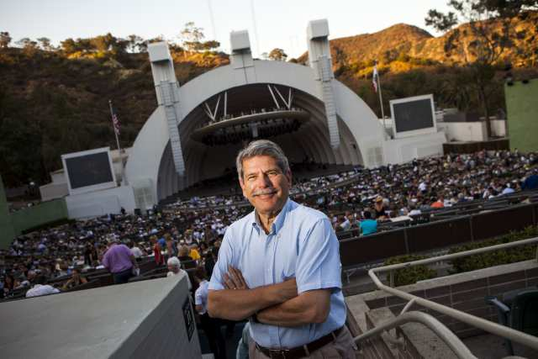
In transportation, he was the driving force behind the Orange Line busway across the San Fernando Valley and he pushed hard for creation of the new light rail Expo Line which will link Santa Monica to downtown Los Angeles. As a member of the powerful Metro board, he has advocated for a subway to the Westside and dedicated bus lanes.
Zev was an early supporter of the Sepulveda Pass “Improvement” Project, which added a carpool lane to the 405. He was also an early critic of the project’s apparently cavalier manner of dealing with issues directly affecting residents in Westwood Hills and elsewhere along its path. Many times during construction Zev’s office stepped in to help. For example, without Zev, there would be no landscaping along our section of Sepulveda Blvd.
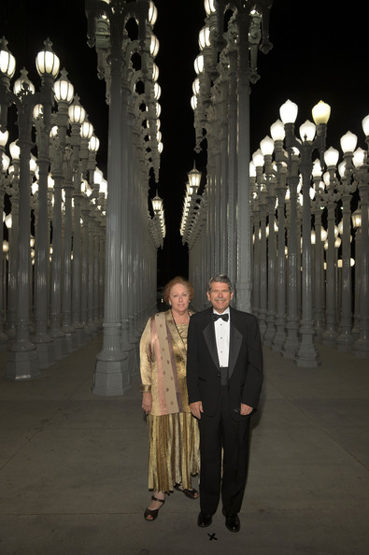
In the area of social and human services, he has launched a series of groundbreaking initiatives that have measurably improved life for individuals and families on the margins of society. He also has been credited with helping to restore the lives of the region’s chronically homeless through his widely praised Project 50 program and its spinoffs which have provided permanent supportive housing for hundreds of people who’ve been identified as most likely to die on the streets.
In the arts, meanwhile, Zev championed efforts to rebuild and modernize the world famous Hollywood Bowl amphitheater and was instrumental in the development of Walt Disney Concert Hall. In recognition of his contributions he was invited to conduct the Los Angeles Philharmonic Orchestra in the playing of our National Anthem and narrated Aaron Copland’s “Lincoln Portrait.” He has also helped fund major investments in the Los Angeles County Museum of Art, the Museum of Natural History and the Valley Performing Arts Center.
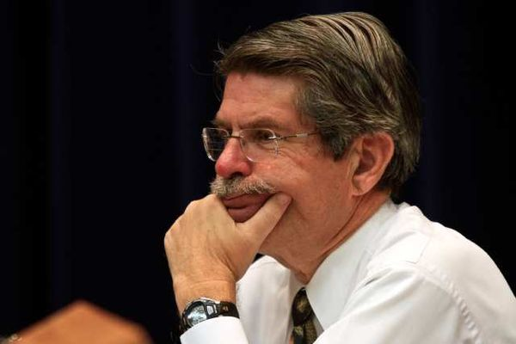
Any consideration of Zev’s contributions and accomplishments, of which only a few have been mentioned here, must include mention of his wonderful wife, Barbara, who has won admiration and affection of the community throughout his public life. Also deserving acknowledgment are his superb staff, many of whom have served since his days as a Councilman. Among them are the outstanding Vivian Rescalvo, Ginny Kruger, Alisa Katz, Maria Chong Castillo and Liz Rangel who have been with him for 40 years.
To Zev, and to his wonderful wife Barbara, the Westwood Hills Property Owners Association joins the residents of Westwood Hills to wish you a long and fulfilling next chapter, with many hours in the company of your family and grandchildren. A heartfelt thank you for your many and lasting gifts to our community.

Thank you to the Holmby-Westwood Property Owners for these photographs

West Nile Virus Alert
A few weeks ago a number of individuals were concerned about dead, sick or injured crows found in different places throughout our neighborhood. Following that, the Los Angeles Times ran a rather lengthy story about a serious outbreak of West Nile Virus in Orange County where 80% of the mosquito samples collected this year tested positive for West Nile Virus. This outbreak precipitated Vector Control to begin spraying various neighborhoods in that county. These events prompted me to do some research on the virus, its causes, effects and prevention.
West Nile Virus, a mosquito-borne virus, came from Africa, Asia and the Middle East. It was found first in Southern California in 2003, and has since spread to all 58 counties. It is transmitted to people and animals when a mosquito feeds on a bird with the virus in its blood and then bites a human or another animal. In general, the virus produces flu like symptoms. Individuals at risk are those over fifty and those with certain medical conditions such as diabetes and high blood pressure. Most people experience no symptoms while some may experience milder ones such as fever, headache, body ache or rash. These can last a few days or several weeks.
A small number of people may develop serious illness with more severe symptoms such as high fever, headache, stiff neck, disorientation, vision loss and more. These may last several weeks and could even produce permanent neurological effects. West Nile Virus can even be fatal.
If you experience any WNV symptoms, you should call your doctor or go to a clinic immediately.
In order for the California Department of Public Health to monitor this virus, dead birds or tree squirrels must be reported to the following: http://www.westnile.ca.gov, or call 1-877-WNV-BIRD (1-877-968-2473)
Dead bird or squirrels are picked up for testing, if they meet certain criteria (one of them, I think, is that it cannot be dead more than 24 hours). If the criteria are not met, the animal or bird will not be picked up and you may dispose of it in an outdoor garbage can. Whatever you do, DO NOT HANDLE THE ANIMAL WITH YOUR BARE HANDS. Use a shovel, glove or inverted plastic bag to handle it. Place the animal first in a plastic bag and then put it in the trash. I suggest that children and pets be kept away from it.
It is very important that you protect yourself during mosquito season. To prevent exposure to mosquitos:
--ELIMINATE ALL SOURCES OF STANDING WATER ON YOUR PROPERTY; this reduces mosquito breeding.
--Avoid being outside at dusk and dawn.
--Apply insect repellent containing DEET, or oil of eucalyptus according to label instructions when you are outside.
--Wear long sleeves.
--Make sure your doors and windows have tight screens.
--Repair or replace damaged screens --Call your local mosquito and Vector Control agency if there is a large mosquito problem where you live or work.
--Buy fish that eat mosquito larva for your fountains
Much of my information came from the LA Times article, "O.C. is alarmed by West Nile," and the California Department of Public Health, Vector-Borne Disease Section in Sacramento, CA. Their brochure "The California West Nile Virus Surveillance System" is very helpful. http://www.cdph.ca.gov/

For those of you who wanted numbers to call for dead animal removal, dial 3-1-1 or contact the West Los Angeles Animal Care Shelter at
1-310-207-3156.

Jane Schwab , Security Committee Chair

Early Morning Visitor on Ophir Drive
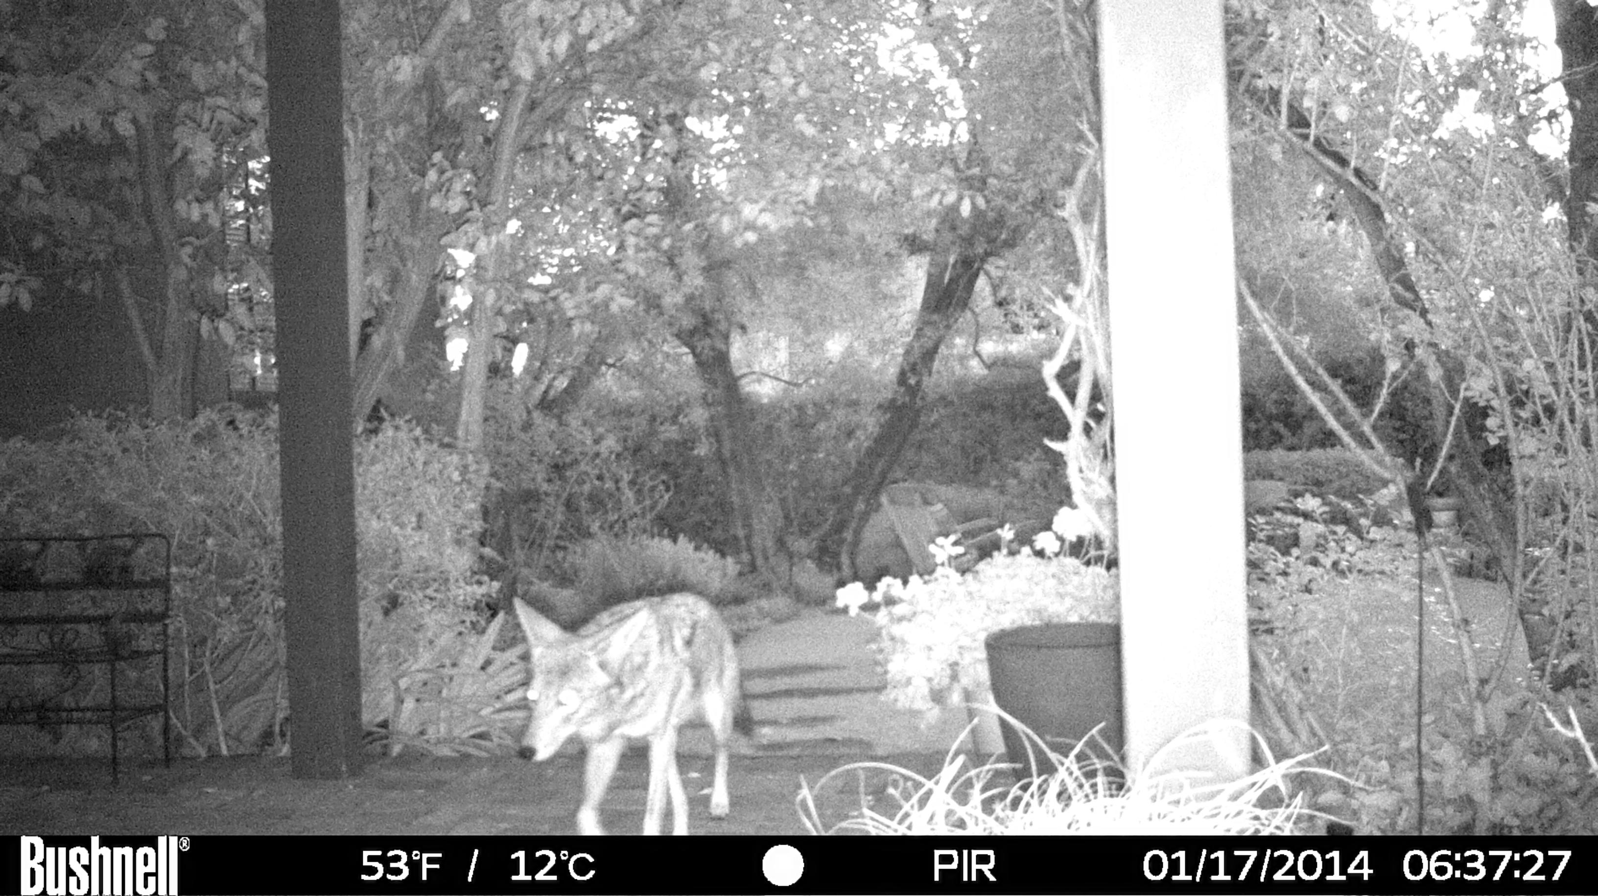

WESTWOOD HILLS PROPERTY OWNERS ASSOCIATION

Officers
Terry Tegnazian
President
Carole Magnuson
Vice President
Alvin Milder, Esq.
Vice President
Margot Barron, CPA
Treasurer
Sue Polep
Secretary
Directors
Aphrodite Banks
Judy Brown
Joe Hilberman
Wayne Hodges
Caroline Lee
Donald Lumpkin
Harry Macy
Debbie Nussbaum
Frank Ponder
Stephen Rohde, Esq.
Jane Schwab
Sherry West
P.O. Box 24515, Los Angeles, CA 90024
E-mail: westwoodhills-owner@yahoogroups.com

This newsletter is published by the Westwood Hills Property Owners Association as a service to members

Board Elections
Each year at the Annual Meeting, WHPOA elects members to serve on its Board of Directors for the coming two years. Candidates for election this year are: Terry Tegnazian (Cashmere), Carole Magnuson (Ophir), Margot Barron, CPA (Tavistock), Sue Polep (Barlock), Judy Brown (Bentley), Harry Macy (Cashmere), Debbie Nussbaum (Cashmere Terrace), Sherry West (Montana) and Stephen Rohde (Montana). Serving the second year of a two-year term are Aphrodite Banks (Veteran), Joe Hilberman (Bentley), Wayne Hodges (Thurston), Caroline Lee (Bentley), Donald Lumpkin (Montana), Alvin Milder, Esq. (Greenfield), Frank Ponder (Homedale), and Jane Schwab (Bronwood).

Not a Member Yet?
WHPOA—the Westwood Hills Property Owners Association—is a 56-year-old all-volunteer organization devoted solely to maintaining the quality of life in the Westwood Hills, a community of 607 single family homes bordered by Sunset Blvd., Veteran Ave., the Veterans Cemetery and Sepulveda Blvd. More than 85% of Westwood Hills residents are members and most of them subscribe to the WHPOA neighborhood email network. Unlike other homeowner organizations, there are no dues, just a one-time payment of $100. For more information and an application, contact our Membership Chairperson at s.polep@gte.net.

Welcome New Members
We would like to welcome the following families who have joined the Westwood Hills Property Owners Association since October 2013: Kenneth Firtel and Jana Posalski; Amy and Ben Weiss; Yassaman and Siamak Vaziri (Barlock) Jay Kwan and Elena Cho; Bethany and Adam Korn; Elizabeth Tsai and Andrew Fond (Bronwood); Kathy and Jean-Philippe Langevin (Cashmere); Andrew Brown and Kimberly Bertz Brown; Carmen Licea-Elliott and Pierce O’Donnell (Dalkeith): Nasim Ravari and Robby Rezaei; Cam Do and Viet Duong (Denslow); Joshua and Stefanie Tam; Nancy and Michael Cohen (Homedale); Jeryll Cohen; Jerry and Masami Torgerson (S. Bentley); Pedram Salehi and Arezoo Nasiry; Fatim and David Fields (Sunset); Mike Robinovick and Svetlana Kotova (S. Thurston); Robbie Brenner and Aaron Sanor (Tilden); Jason and Liana Eng; Julia and Rick Shuart; Clarence Braddock III and Janet Leader (Veteran). We apologize if your name is missing. Please email westwoodhills-owner@yahoogroups.com
Join the email network! Easy to do. Simply email your name
and address to Westwoodhills-owner@yahoogroups.com.

